**TITLE OF THE PROJECT**

**A Skill Oriented Course Web Application report** Submitted in the partial fulfilment of the requirements for the award of the degree of

Bachelor of Technology In

Computer Science and Engineering

by

# ORSU. USHA SREE

# 23761A05H0

Under the guidance of

**Mr. M. Kiran Kumar,**

**Sr. Assistant Professor, Dept. of CSE**



**Department of Computer Science and Engineering Lakireddy Bali Reddy College of Engineering (Autonomous) Accredited by NAAC & NBA (Under Tier - I)**

# Affiliated to JNTUK, Kakinada; ISO 9001:2015 Certified

**2023-24**

|  |  |
| --- | --- |
|  | **LAKIREDDY BALI REDDY COLLEGE OF ENGINEERING**  **(An Autonomous Institution since 2010)**  **Accredited by NAAC with ‘A’ Grade & NBA (Under Tier - I),**  **An ISO 21001:2018, 14001:2015, 50001:2018 Certified Institution**  **Approved by AICTE, New Delhi and Affiliated to JNTUK, Kakinada**  **L.B. REDDY NAGAR, MYLAVARAM, NTR DIST., A.P.-521 230.**  [hodcse@lbrce.ac.in,](mailto:hodcse@lbrce.ac.in,%20) [cseoffice@lbrce.ac.in,](mailto:cseoffice@lbrce.ac.in,%20) Phone: 08659-222 933, Fax: 08659-222931  **DEPARTMENT OF COMPUTER SCIENCE & ENGINEERING** |

**CERTIFICATE**

This is to certify that the **“23CSS2-Full Stack Development -I”** project entitled “**Café Coffee Day Online Booking**” is being submitted by  **ORSU. USHA SREE (23761A05H0)** in partial fulfilment for the award of B. Tech in Computer Science & Engineering to the Jawaharlal Nehru Technological University Kakinada is a record of bonafide work carried out by him/her under our guidance.

The results embodied in this Skill Oriented Course Web Application / Project report have not been submitted to any other University or Institute for the award of any degree or diploma.

## Project Guide Head of the department

Mr. M. Kiran Kumar, Dr. D. Veeraiah,

Sr. Assistant Professor. Professor.

## External Examiner

**ACKNOWLEDGEMENT**

I would like to thank **Mr. M. Kiran Kumar,** Sr.Assistant Professor**,** CSE department for encouraging and support in carrying out this Skill Oriented Course Web Application.

I also take the privilege to record my thanks to **Dr. D. Veeraiah,** Professor, Head of the Department of CSE whose encouragement, cooperation and valuable support crown my success.

I express my thanks to the support given by management in completing my Web Application / Project. I also express my sincere gratitude & deep sense of respect to the Principal, **Dr. K. Appa Rao** for making us available all the required assistance and his support and inspiration to carry out this Skill Oriented Course Web Application / Project in the Institute.

I am thankful to the teaching and non-teaching staff of CSE department for their direct as well as indirect help in my Skill Oriented Course Web Application / Project.

I am elated to avail my selves to this opportunity to express my deep sense of gratitude to my parents.

## ABSTRACT

**CONTENTS**

## CONCEPTS

## Page No:1

1. Introduction
2. Modules
3. Technologies Used
   1. HTML
   2. CSS
   3. JAVA SCRIPT
4. Implementation
   1. HTML Code
5. Screen Shots
6. Conclusion
7. Web References

1.Introduction

In today's digital era, customer convenience and seamless service are key to a successful business. Cafe Coffee Day (CCD), one of India's leading coffee chains, caters to millions of customers daily. To enhance the customer experience and streamline operations, this project introduces an Online Booking System for Cafe Coffee Day.

The Cafe Coffee Day Online Booking System is a web-based platform that allows customers to reserve tables at their preferred CCD outlet in advance. This system is especially useful during peak hours, weekends, or special occasions when cafes are usually crowded. Customers can select the date, time, number of guests, and even their preferred location, all from their mobile devices or computers.

The main objective of this project is to:

Reduce waiting times at CCD outlets.

Improve customer satisfaction by ensuring reservation availability.

Provide an efficient way for staff to manage table reservations and customer flow.

The application is developed using core front-end technologies—HTML for structure, CSS for styling, and JavaScript for functionality. It focuses on ease of use, responsive design, and smooth navigation. In the future, this platform can be expanded to include features like digital menus, online orders, customer feedback, and payment integration.

This project showcases how digital tools can elevate a traditional coffee shop experience into a smart and convenient journey for customers.

2. Modules

The Cafe Coffee Day Online Booking system is divided into several functional modules, each responsible for handling specific tasks to ensure a smooth booking experience:

1. Home Page Module

Provides an overview of the website.

Displays a welcome message, latest offers, and highlights of the booking service.

2. User Registration & Login Module

Allows new users to create an account.

Enables existing users to log in securely.

Maintains user session and personalized experience.

3. Outlet Selection Module

Displays a list of Cafe Coffee Day outlets by city or region.

Includes search and filter functionality to help users find their preferred location.

4. Table Booking Module

Lets users select date, time, number of guests, and preferred outlet.

Shows availability status in real-time.

Confirms booking and provides a reference/confirmation ID.

5. Booking Management Module

Allows users to view, modify, or cancel existing bookings.

Sends booking confirmation and reminder alerts via email/SMS (optional feature).

6. Admin Module (Optional)

Lets administrators manage outlets, table availability, and monitor bookings.

Provides data on usage statistics and customer feedback (for future enhancement).

7. Contact & Support Module

Offers help or FAQs for users.

Includes a contact form for customer service.

3. Technologies Used

To develop the Cafe Coffee Day Online Booking system, the following web technologies have been used:

Front-End Technologies:

1. HTML (HyperText Markup Language)

Used to structure the content and layout of the web pages.

Elements like forms, buttons, and navigation menus are created using HTML.

2. CSS (Cascading Style Sheets)

Used to style the HTML elements and enhance the visual appearance of the website.

Enables responsive design for mobile and desktop views.

CSS is applied for layouts, fonts, colors, animations, and transitions.

3. JavaScript

Adds interactivity and dynamic behavior to the web pages.

Used for form validation, real-time availability checks, and responsive actions like showing booking confirmations or alerts.

4. Implementation

HTML CODE

(Cafe coffee day.html)

<!DOCTYPE html>

<html lang="en">

<head>

<meta charset="UTF-8">

<meta name="viewport" content="width=device-width, initial-scale=1.0">

<title>Section Page</title>

<style>

/* Reset default margin and padding */

* {

margin: 0;

padding: 0;

box-sizing: border-box;

}

/* Navigation bar styles */

nav {

background-color: #333;

padding: 10px;

text-align: center;

}

nav ul {

list-style-type: none;

padding: 0;

display: flex;

justify-content: center;

}

nav ul li {

margin: 0 15px;

}

nav ul li a {

color: white;

text-decoration: none;

font-size: 18px;

}

nav ul li a:hover {

color: #f4a261;

}

/* Main content area *

.main-content {

padding: 20px;

text-align: center;

background-color: #f4f4f4;

min-height: 60vh;

}

.logo img {

width: 50px;

height: auto;

margin-right: 10px;

}

font-family: Arial, sans-serif;

background: #f4f4f4;

display: flex;

justify-content: center;

align-items: center;

height: 100vh;

}

.login-container {

background: #fff;

padding: 2rem;

border-radius: 10px;

box-shadow: 0 0 10px rgba(0,0,0,0.1);

width: 300px;

}

.login-container h2 {

text-align: center;

margin-bottom: 1.5rem;

}

.login-container input {

width: 80%;

padding: 10px;

margin-bottom: 1rem;

border: 1px solid #ccc;

border-radius: 5px;

}

.login-container button {

width: 80%;

padding: 10px;

background: #007BFF;

color: white;

border: none;

border-radius: 5px;

cursor: pointer;

}

.login-container button:hover {

background: #0056b3;

}

/* Footer styles */

footer {

background-color: #333;

color: white;

text-align: center;

padding: 10px;

position: relative;

bottom: 0;

width: 100%;

}

</style>

</head>

<body>

<div class ="logo">

<img src="logo.jpg" alt="logo">

</div>

<!-- Navigation Bar -->

<nav>

<ul>

<li><a href="#home">HOT CLASSICS</a></li>

<li><a href="#about">ALL-TIME CHILLERS</a></li>

<li><a href="#services">ALL-TIME CHILLERS</a></li>

<li><a href="#contact">ALL-TIME DELIGHTS</a></li>

<li><a href="#sweet">SWEET TOOTH</a></li>

<li><a href="#nutritional">NUTRITIONAL INFO</a></li>

</ul>

</nav>

<!-- Main Content -->

<div class="main-content">

<h1> CAFE COFFEE DAY ONLINE BOOKING</h1>

<img src="C:\Users\user\Pictures\mobile-new-menu-cafe-coffee-day1.jpg" alt="cafe" width="1000" height="500"/>

</div>

<!-- Footer -->

<footer>

<nav>

<ul>

<li><a href="hot classics.html">HOT CLASSICS</a></li>

<li><a href="all 1.html">ALL-TIME CHILLERS</a></li>

<li><a href="all 2.html">ALL-TIME CHILLERS</a></li>

<li><a href="all del ights.html">ALL-TIME DELIGHTS</a></li>

<li><a href="sweet.html">SWEET TOOTH</a></li>

<li><a href="nutritional info.html">NUTRITIONAL INFO</a></li>

<li><a href="login.html">LOGIN</a></li>

</ul>

</nav>

</footer>

</body>

</html>

(Hot classics.html)

<div class="content">

<img src="C:\Users\user\Desktop\cafe_coffee_1\HOT CLASSICS 1.jpg" alt="centered image" width="1000" height="1000"/></br>

<img src="C:\Users\user\Desktop\cafe_coffee_1\HOT CLASSICS 2.jpg" width="1000" height="1000"/>

</div>

(All time chillers.html)

<div class="content">

<img src="C:\Users\user\Desktop\cafe_coffee_1\1st ALL TIME CHILLERS 1.jpg" alt="centered image" width="1000" height="1000"/></br>

<img src="C:\Users\user\Desktop\cafe_coffee_1\1st ALL TIME CHILLERS 2.jpg" width="1000" height="1000"/>

</div>

(All time chillers.html)

<div class="content">

<img src="C:\Users\user\Desktop\cafe_coffee_1\2nd ALL TIME CHILLERS 1.jpg" alt="centered image" width="1000" height="1000"/></br>

<img src="C:\Users\user\Desktop\cafe_coffee_1\2nd ALL TIME CHILLERS 2.jpg" width="1000" height="1000"/>

</div>

(All time delights.html)

<div class="content">

<img src="C:\Users\user\Desktop\cafe_coffee_1\ALL DAY DELIGHTS 1.jpg" alt="centered image" width="1000" height="1000"/></br>

<img src="C:\Users\user\Desktop\cafe_coffee_1\ALL DAY DELIGHTS 2.jpg" width="1000" height="1000"/>

</div>

(Sweet tooth.html)

<div class="content">

<img src="C:\Users\user\Desktop\cafe_coffee_1\SWEET TOOTH X32 1.jpg" alt="centered image" width="1000" height="1000"/></br>

<img src="C:\Users\user\Desktop\cafe_coffee_1\SWEET TOOTH X32 2.jpg" width="1000" height="1000"/>

</div>

(Nutritional info.html)

<div class="content">

<img src="C:\Users\user\Desktop\cafe_coffee_1\FOOD nutritional info.jpg" alt="centered image" width="1000" height="1000"/></br>

</div>

(login.html)

<div class="login-container">

<h2>Login</h2>

<form action="/login" method="post">

<input type="text" name="username" placeholder="Username" required />

<input type="password" name="password" placeholder="Password" required />

<button type="submit">Log In</button>

</form>

</div>

5.Screen Shots

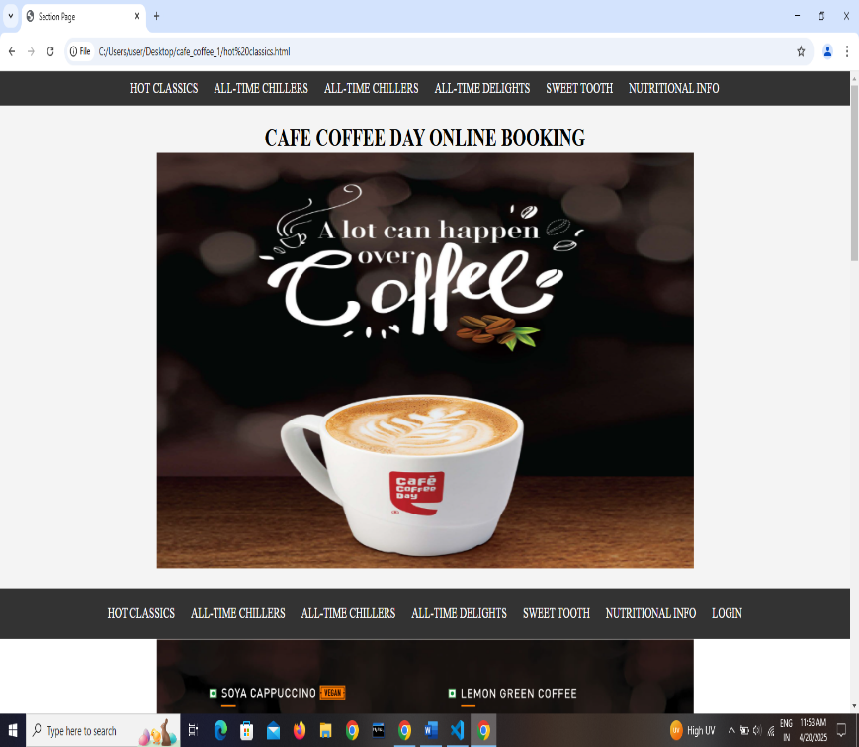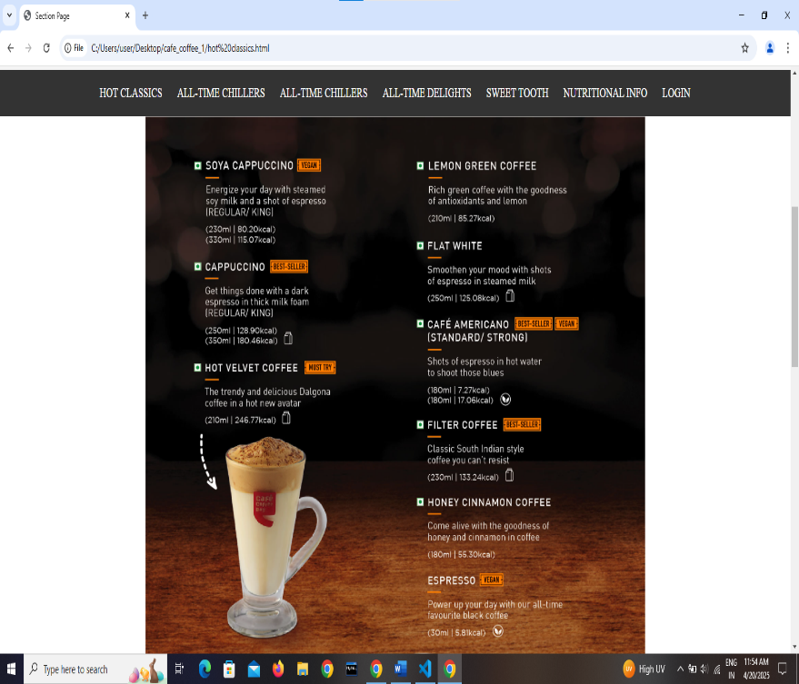

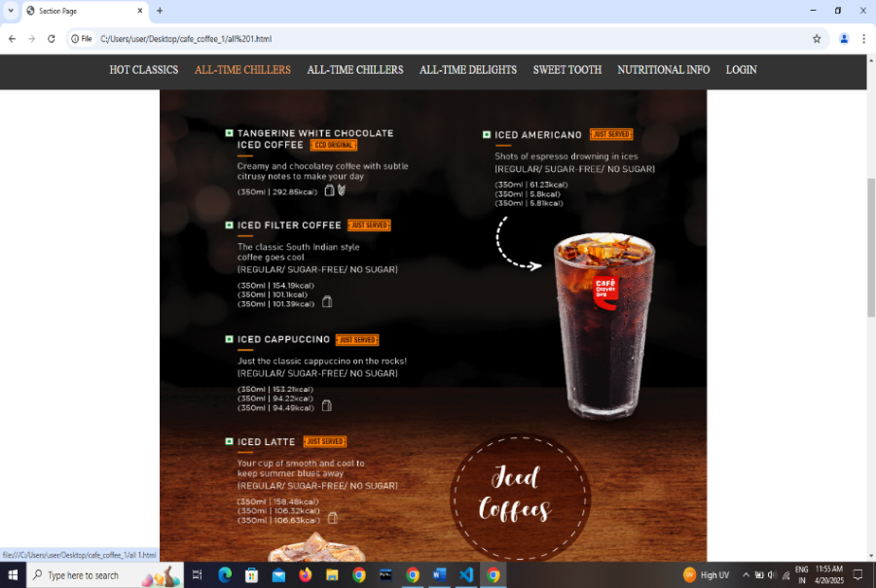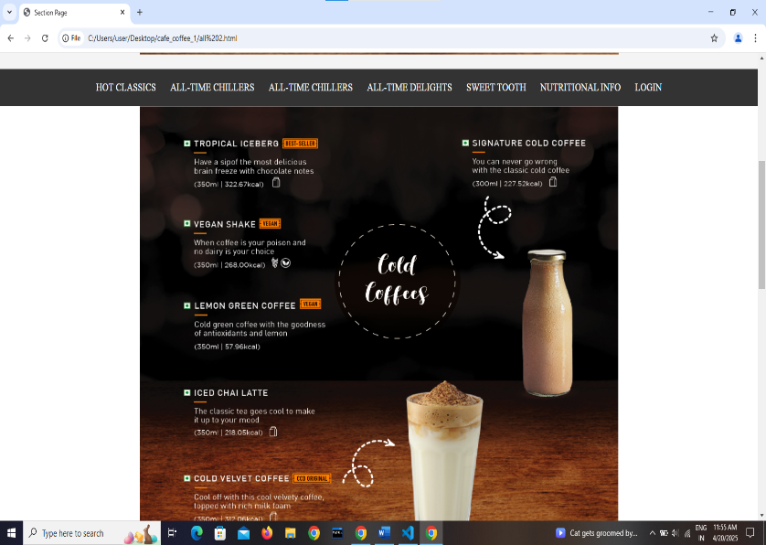  
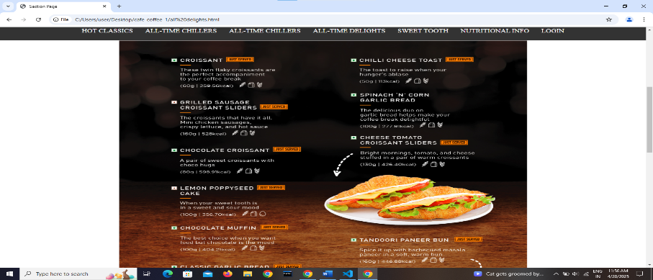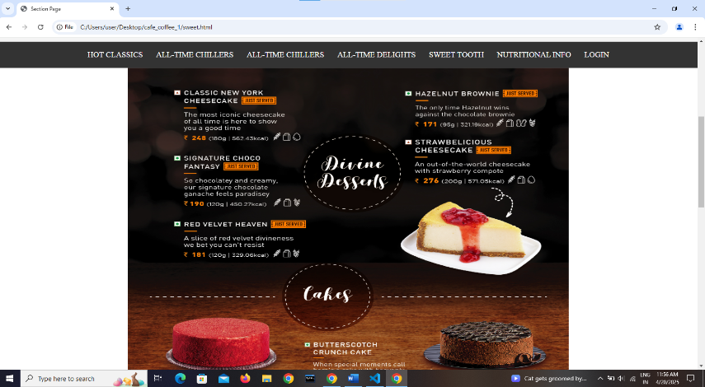

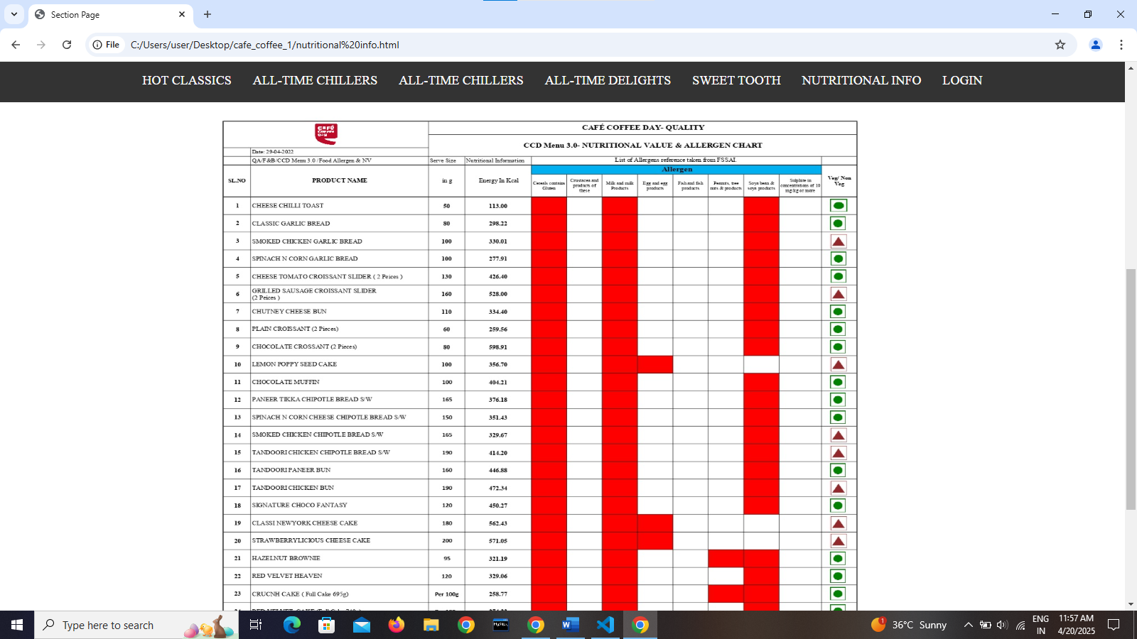

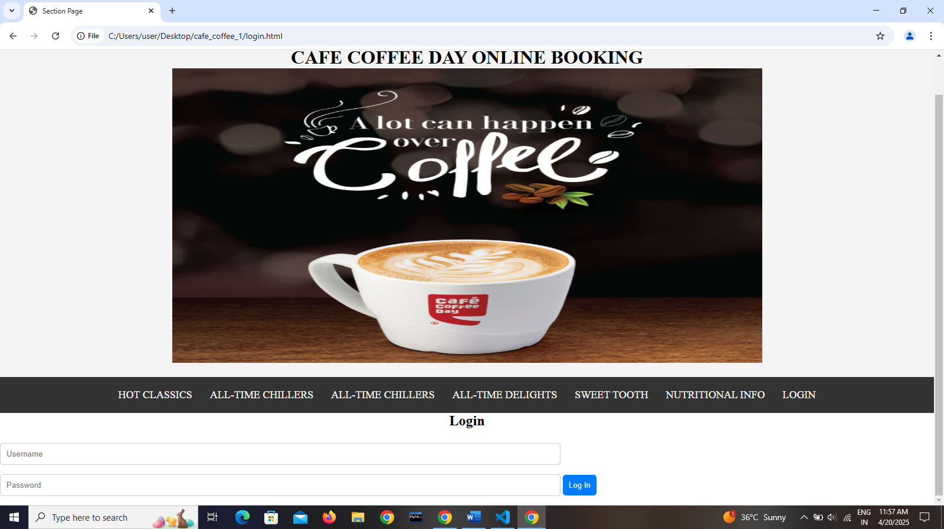

6. Conclusion

The Cafe Coffee Day Online Booking System successfully demonstrates how digital solutions can enhance customer convenience and streamline service operations. By allowing users to reserve tables online, the system helps reduce waiting times, improves customer satisfaction, and optimizes staff management at CCD outlets.

Through the use of HTML, CSS, and JavaScript, a user-friendly and visually appealing interface has been created. The modular design of the application ensures scalability and provides a strong foundation for future enhancements like online ordering, payment integration, and loyalty programs.

This project not only reflects the practical application of front-end web development skills but also highlights the potential of technology in transforming traditional service experiences into seamless digital interaction.

7.Web References

https://www.google.com/search?q=cafe+cofee+on%3Bine+boking&oq=cafe+cofee+on%3Bine+boking&gs_lcrp=EgZjaHJvbWUyBggAEEUYOdIBCTEwNDMwajBqMagCALACAQ&sourceid=chrome&ie=UTF-8